https://signups.motimate.app/nb/org/dnt

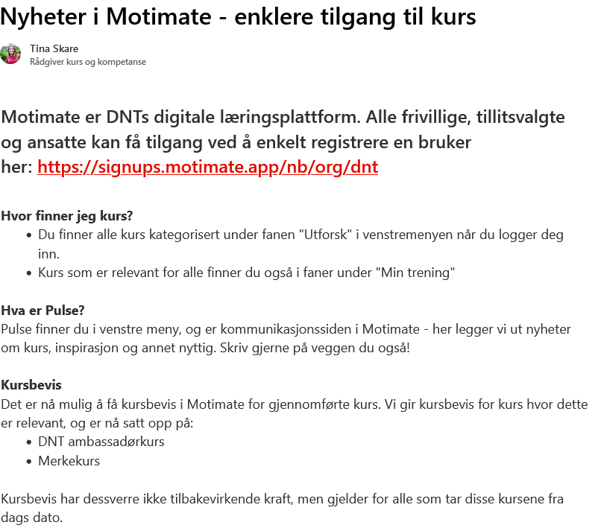
Mer info finner du på foreningsnett:
https://dennorsketuristforening.sharepoint.com/sites/DNT-Skolen/SitePages/Nyheter-i-Motimate.aspx?from=DigestNotification&e=0VQm0w59sE-SfFmI1NnGNg&at=9&CT=1667479987072&OR=OWA-NT&CID=c55e0852-f451-52c8-9a1a-3057237eca8e

